Deniz Muratlı, 29480

2) I chose the tables Albums and Artists. The primary key of Artists is a foreign key in Albums. However, this necessitated me to also fill in Labels, as Albums has a foreign key referencing that table too.

3)

INSERT INTO Labels VALUES (1, "Columbia Records", "https://www.columbiarecords.com/", "USA", 1889);

INSERT INTO Labels VALUES (2, "Kalan Muzik", "https://kalan.com/", "Turkey", 1991);

INSERT INTO Labels VALUES (3, "Seyhan Muzik", "http://www.seyhanmuzik.com/", "Turkey", 1987);

INSERT INTO Labels VALUES (4, "EMRE", "https://www.emreplak.com.tr/", "Turkey", 1970);

INSERT INTO Labels VALUES (5, "Elektra Records", "https://www.elektra.com/", "USA", 1950);

INSERT INTO Labels VALUES (6, "RMV Grammofon", "https://rmvgrammofon.com/", "Sweden", 2010);

INSERT INTO Labels VALUES (7, "Liberation Records", "http://www.liberationrecords.com/", "USA", 1994);

INSERT INTO Labels VALUES (8, "Yavuz Burc Plakcilik", "http://www.yavuzburcplak.com", "Turkey", 1961);

INSERT INTO Labels VALUES (9, "Smithsonian Folkways", "https://folkways.si.edu/", "USA", 1987);

INSERT INTO Artists VALUES (1, "Person", "Pete Seeger", "USA", 1940);

INSERT INTO Artists VALUES (2, "Band", "Grup Yorum", "Turkey", 1985);

INSERT INTO Artists VALUES (3, "Band", "Dinmeyen", "Turkey", 1991);

INSERT INTO Artists VALUES (4, "Band", "Mogollar", "Turkey", 1967);

INSERT INTO Artists VALUES (5, "Person", "Phil Ochs", "USA", 1962);

INSERT INTO Artists VALUES (6, "Choir", "Socialdemokraternas Jubileumskor", "Sweden", 2019);

INSERT INTO Artists VALUES (7, "Person", "Billy Bragg", "UK", 1977);

INSERT INTO Artists VALUES (8, "Person", "Cem Karaca", "Turkey", 1961);

INSERT INTO Artists VALUES (9, "Person", "Joan Baez", "USA", 1958);

INSERT INTO Artists VALUES (10, "Person", "Nathalie Cardone", "France", 1988);

INSERT INTO Albums VALUES (1, "I Can See a New Day (Live)", 1964, 1, 1);

INSERT INTO Albums VALUES (2, "Ille Kavga", 2017, 2, 2);

INSERT INTO Albums VALUES (3, "Sisler Bulvari", 2006, 3, 3);

INSERT INTO Albums VALUES (4, "Dort Renk", 1996, 4, 4);

INSERT INTO Albums VALUES (5, "Phil Ochs in Concert", 1966, 5, 5);

INSERT INTO Albums VALUES (6, "Pa ratt sida av historien", 2019, 6, 6);

INSERT INTO Albums VALUES (7, "The Internationale", 1990, 7, 7);

INSERT INTO Albums VALUES (8, "Haziranda Olmek Zor / Berivan", 1991, 2, 2);

INSERT INTO Albums VALUES (9, "Nerdesin", 1975, 8, 8);

INSERT INTO Albums VALUES (10, "If I Had a Hammer: Songs of Hope and Struggle", 1998, 9, 1);

4) Albums:

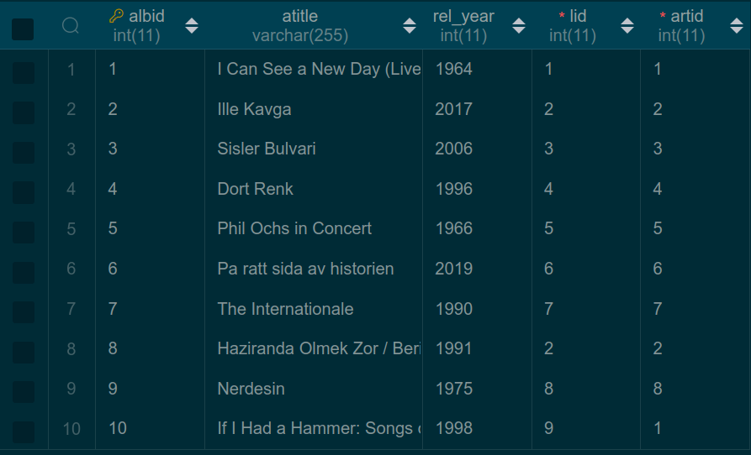

Artists:

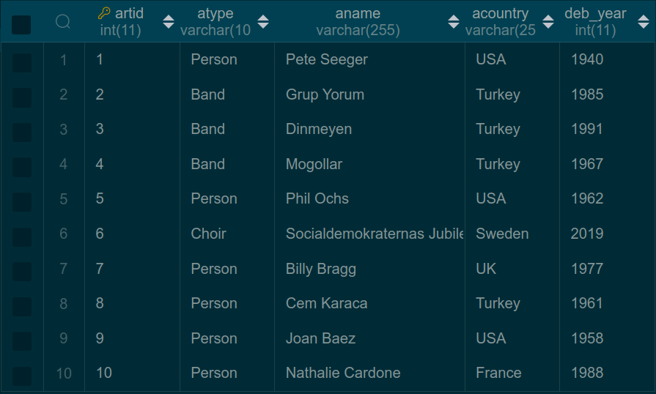

5) Query in English: Find the debut year of the artist for each album in the “Albums” table.

Query in relational algebra: πdeb_year (Albums ⋈Albums.artid = Artists.artid Artists)

6)

SELECT deb_year

FROM Albums Alb JOIN Artists Art ON Alb.artid = Art.artid

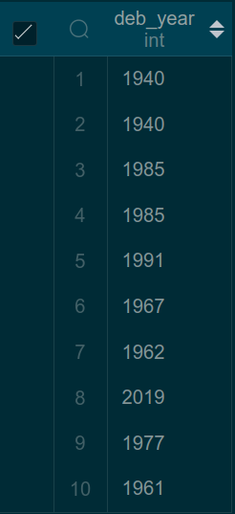

7) Query in English: Calculate the total number of albums released by each artist in each country, and display the artist's country, name, and the total number of albums they have released.

Query in SQL:

SELECT Art.acountry, Art.aname, COUNT(Alb.albid)

FROM Artists Art JOIN Albums Alb ON Art.artid = Alb.artid

GROUP BY Art.acountry, Art.aname;

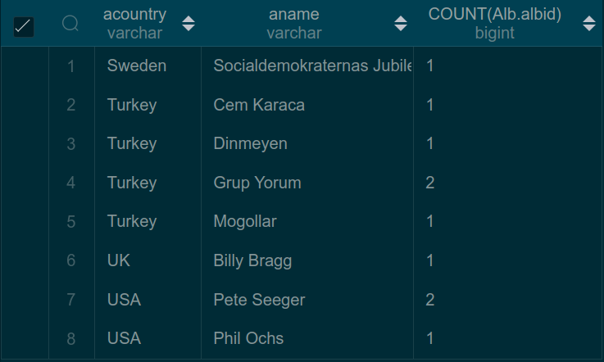

8)

Constraint preventing the insertion of multiple albums within the same year by the same artist:

ALTER TABLE Albums

ADD CONSTRAINT Unique_Release_Year CHECK (

NOT EXISTS (SELECT *

FROM Albums A

WHERE A.artid = artid AND A.rel_year = rel_year AND A.albid != albid)

);

A statement that violates the check condition:

INSERT INTO Albums VALUES (11, "New Album", 1998, 9, 1);